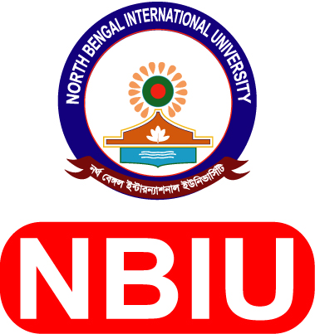
North Bengal International University

Attached:
PP size picture
(2 copies)
Application Form for Teaching Position
Registrar
Campus: Chowddopai, Natore Road, Binodpur Bazar, Motihar, Rajshahi.
E-mail: career@nbiu.edu.bd
bKash TrxID: ..............................., Payment Date: ......................

- Name of the Post: Dept. / Subject :

- Applicant’s Name (English): (Bangla):

- Father’s Name :

- Mother’s Name :

- Mobile / Phone Number : E-mail :

- Date of Birth (d/m/y):

- Nationality & ID Number:

- Blood Group :

- Address : a) Present :

b) Permanent:

- Educational Background :

Exam / Degree | Group / Discipline | Institution/Board  / University | Session Year | Passing Year | CGPA / Division
Ph.D.

M.Phil.

Masters

Bachelor / Hon’s
Diploma

HSC / A-Level

SSC / O-Level

Note : Copies of all certificates & Transcripts should be attached

- Study of Courses :
a) Ph.D :

b) M.Phil :

c) Masters :

d) Bachelor / Hon’s :

- Sex :

- Marital Status :

- Computer Proficiency :

- Language Proficiency :

- Publications : Total : a) International Journal : b) National Journal :

(Use extra page to give details)

- Research / Project work (if any after tertiary education ):

- Participation in Conference, Seminar, Symposium, Workshop, etc. (Home & Abroad):

- Training :

- Experience (Teacher / Researcher):
Institution’s Name | Designation | Date of Joining | Date of  Resignation | Teaching subjects as a Teacher / Researcher
Note : NO Objection Certificate (NOC) from Present organization must be enclosed : (If applicable)
21. Referees: a ) b)

Applicant‘s Signature: Date :

