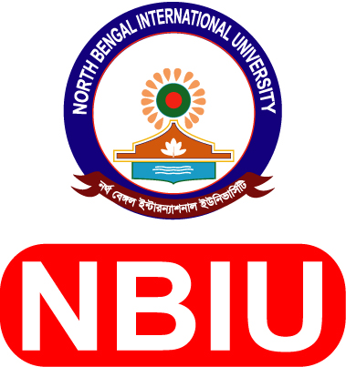
North Bengal International University

Attached:
PP size picture
(2 copies)
Application Form for Official
Registrar
Campus: Chowddopai, Natore Road, Binodpur Bazar, Motihar, Rajshahi.
E-mail: career@nbiu.edu.bd
bKash TrxID: ..............................., Payment Date: ......................

- Name of the Post : Section/Dept. :
- Applicant’s Name (English) : (Bangla) :
- Mobile / Phone Number : E-mail :
- Date of Birth (d/m/y) : Age :
- Nationality : NID Number :
- Address : a) Present :

b) Permanent:

- Educational Background :

Exam/Degree | Group/Discipline | Institution/Board/University | Session/Year | Passing Year | CGPA/Division
SSC / O-Level
HSC / A-Level
Bachelor/Hon’s
Masters
Other
Note: Copies of all certificates & Transcripts should be attached

- Sex :
- Marital Status :
- Computer Proficiency :
- Language Proficiency :
- Training :
- Experience :
Institution’s Name | Designation | Date of Joining | Date of Resignation

14. Referees: a ) b)

Submitted Date : Applicant‘s Signature:

